A MINI PROJECT REPORT

ON

**“Vehicle Number Plate Detection”**

SUBMITTED IN PARTIAL FULFILLMENT OF THE REQUIREMENT FOR THE DEGREE OF

BACHELOR OF COMPUTER ENGINEERING

BY

**Omkar Bhosale (55)**

**Chirag Gaigawale (57)**

**Siddhi Thakure (60)**

UNDER GUIDANCE OF

**Prof Chhaya Pawar**



**UNIVERSITY OF MUMBAI**

**DEPARTMENT OF COMPUTER ENGINEERING**

**DATTA MEGHE COLLEGE OF ENGINEERING**

*PLOT NO.98 SECTOR-3, AIROLI, NAVI MUMBAI*

**ACADAMIC YEAR 2017-18**



**DATTA MEGHE COLLEGE OF ENGINEERING**

**AIROLI, NAVI MUMBAI**

**CERTIFICATE**

This is to certify that the project entitled “Mini **Project title**” is bona fide work of “**Name of the students separated by comma** “ submitted to the University of Mumbai in partial fulfilment of the requirement for the award of the degree of **“Undergraduate”** in **“Computer Engineering”**.

Prof Chhaya Pawar Prof. A. P. Pande Dr.S.D.Sawarkar Project Guide Head of the Department Principal



**DATTA MEGHE COLLEGE OF ENGINEERING**

**AIROLI, NAVI MUMBAI**

**PROJECT APPROVAL**

This project report entitled “**Project title**” of the students “**Name of the students separated by comma”** approved for the degree of **Computer Engineering.**

A. B. C. X. Y. Z.

Internal Examiner External Examiner

Date: Date:

Place: Place:

**DECLARATION**

We declare that, this written submission represents our ideas in our own words and where others' ideas or words have been included; we have adequately cited and referenced the original sources. We also declare that, we have adhered to all principles of academic honesty and integrity and have not misrepresented or fabricated or falsified any idea/data/fact/source in our submission. We understand that any violation of the above will be cause for disciplinary action by the Institute and can also evoke penal action from the sources which have thus not been properly cited or from whom proper permission has not been taken when needed.

Name of the Students Signature

Omkar Bhosale

Chirag Gaigawale

Siddhi Thakure

**ACKNOWLEDGEMENT**

Motivation and guidance are the keys towards success. I would like to extend my thanks to all the sources of motivation.

We would like to grab this opportunity to thank **Dr. S. D. Sawarkar, Principal** for encouragement and support he has given for our project.

We express our deep gratitude to **Prof. A. P. Pande, Head of the Department** who has been the constant driving force behind the completion of this project.

We wish to express our heartfelt appreciation and deep sense of gratitude to my project guide **Prof. - - -** for his/her encouragement, invaluable support, timely help, lucid suggestions and excellent guidance which helped us to understand and achieve the project goal. His/Her concrete directions and critical views have greatly helped us in successful completion of this work.

We extend our sincere appreciation to all Professors for their valuable inside and tip during the designing of the project. Their contributions have been valuable in so many ways that we find it difficult to acknowledge of them individually.

We are also thankful to all those who helped us directly or indirectly in completion of this work.

Place: Name of the student

Date:

**INDEX**

|  |  |  |  |  |
| --- | --- | --- | --- | --- |
| 1. | INTRODUCTION | | |  |
|  | Motivation  Aim &Objective | |  |  |
| 2. | LITERATURE SURVEY | | |  |
|  |  |  | |  |
| 3. | EXISTING SYSTEM | | |  |
|  |  |  | |  |
| 4. | PROPOSED SYSTEM | | |  |
|  |  | Architecture/ Framework | |  |
|  |  | Technology used | |  |
|  |  | Details Of Hardware and Software | |  |
| 5. | Analysis of Algorithm | | |  |
|  |  | DFD /sequence diagram  PERT/Gantt chart | |  |
| 6. | RESULTS AND DISCUSSIONS | | |  |
|  |  |  | |  |
| 7. | CONCLUSIONS AND FUTURE SCOPE | | |  |
|  |  |  | |  |
| 8. | REFERENCES | | |  |
|  |  |  | |  |

**LIST OF FIGURES**

|  |  |  |
| --- | --- | --- |
| **SR. NO.** | **NAME OF THE FIGURE** | **PAGE NO.** |
| 1 | Sentence Case | 1 |
| 2 | Sentence Case |  |
| 3 | Sentence Case |  |
| 4 | Sentence Case |  |
| 5 | Sentence Case |  |
| 6 | Sentence Case |  |
| 7 | Sentence Case |  |
| 8 | Sentence Case |  |
| 9 | Sentence Case |  |
| 10 | Sentence Case |  |
| 11 | Sentence Case |  |

**LIST OF TABLE**

|  |  |  |
| --- | --- | --- |
| **SR. NO.** | **NAME OF THE TABLE** | **PAGE NO.** |
| 1 | Sentence Case | 1 |
| 2 | Sentence Case |  |
| 3 | Sentence Case |  |
| 4 | Sentence Case |  |
| 5 | Sentence Case |  |
| 6 | Sentence Case |  |
| 7 | Sentence Case |  |
| 8 | Sentence Case |  |
| 9 | Sentence Case |  |
| 10 | Sentence Case |  |
| 11 | Sentence Case |  |

**ABSTRACT**



The above simulation represents working of our project. Our primary focus is to develop a system that automatically detects number plate and updates the database frequently by inserting the vehicle number entering/leaving the society premises.

Our aim is that ANPR (Automatic Number Plate Recognition) technology should be accesible by the common people. Security guards can capture number plate of vehicles by a single click on their system followed by automatic entry of vehicle number in the database. The growing affluence of urban India has made the ownership of vehicles a necessity. This has resulted in an unexpected civic problem - that of traffic control and vehicle identification. Parking areas have become overstressed due to the growing numbers of vehicles on the roads today. The Automatic Number Plate Recognition System (ANPR) plays an important role in addressing these issues as its application ranges from parking admission to monitoring urban traffic and to tracking automobile thefts. There are numerous ANPR systems available today which are based on different methodologies. In this paper, we attempt to review the various techniques and their usage.

**Introduction**

The massive integration of information technologies, under different aspects of the modern world, has led to the treatment of vehicles as conceptual resources in information systems. Since an autonomous information system has no meaning without any data, there is a need to reform vehicle information between reality and the information system. This can be achieved by human agents or by special intelligent equipment that will allow identification of vehicles by their registration plates in real environments. Among intelligent equipment, mention is made of the system of detection and recognition of the number plates of vehicles.The system of vehicle number plate detection and recognition is used to detect the plates then make the recognition of the plate that is to extract the text from an image and all that thanks to the calculation modules that use location algorithms, segmentation plate and character recognition.The detection and reading of license plates is a kind of intelligent system and it is considerable because of the potential applications in several sectors which are quoted.

* **Motivation:**

In India we know that on various places where we visited with our own vehicle they maintain record of vehicles before we enters in premises of building or office. For maintaining records generally they use a Register and manually enters the details of each and every vehicle. As we know that to make the pages of the registers or any book the raw material required is gathered by cutting thousands of tress. Global Warming is one of the biggest crisis that world is facing so by saving the tress we can definitely make our contribution to save our motherland from such crisis. Another important thing is to keep manually maintained records for long time is not feasible as there is possibility of loss of the records but in computers memory technically we can store data for long time and to capture that data we requires very less time.

* **Aim & Objective**:

The aim of this project to reduce manual work and bring automation in record maintaining system and to see if model is capable of maintaining that data as intelligently as humans.

**LITERATURE SURVEY**

S.Roy, A. Choudhury, J. Mukherjee. [1] The proposed a system to localization of number plate mainly for the vehicles in West Bengal (India) and segmented the numbers as to identify each number separately. This paper presents an approach based on simple and efficient morphological operation and sobel edge detection method. He also presents a simple approach to segmented all the letters and numbers used in the number plate. After reducing noise from the input image we try to enhance the contrast of the binarized image using histogram equalization. S. Du, M. Shehata, W. Badawy [2] Describe a comprehensive survey on existing (Automatic License Plate Recognition) ALPR Techniques by categorizing them according to the features used in each stage. Comparisons of them in the terms of Pros, Cons, Recognition results, & Processing speeds were addressed. A future forecast for ALPR was also given at the end. P. anishiya, prof. S. Mary Joans [3] focused a number plate localization and recognition system for vehicles in Tamilnadu (India) is proposed. This system is developed based on digital images and can be easily applied to commercial car park systems for the use of documenting access of parking services, secure usage of parking houses and also to prevent car theft issues.

**EXISTING SYSTEM**

Vehicle identification has been an active research for over the last few years. A number of researches have been carried outto identify the type of vehicle such as a car, truck, scooter or motorcycle. In [4], Soble filter was used to address this issue to find the edges of the vehicle which in turn is applied to recognize the type of vehicle. The Contourlet Transform and Support Vector Machine (SVM) were used in [5] to find out the model of the vehicle. They showed numerical results on data set of about 70 pictures. However, they did not apply the technique to real-time video stream. In [6] monocular images are used for vehicle recognition. They applied canny edge detection to detect the presence of vehicle and SVM to recognize the vehicle. In [7],Maximum Average Correlation Height (MACH) filter and Log r-theta Mapping techniques were applied to recognize the type of vehicle irrespective of scale and rotation variation of vehicles. The MACH filter was used for detection of targets in cluttered environment. In [8], MACH was used to filter recognize the target to orientation invariance and they used log r-theta mapping to create in-plane rotation and scale invariance while recognition.

In [9], Optical Character Recognition (OCR) technique was used, which is a widely used technology which translates scanned images of printed text into machine encoded text. Here, an OCR algorithm based on feed-forward neural network is being proposed where two non-overlapping real character image data sets are used for training and testing the proposed neural network. The two non-overlapping image data sets were used to emulate real-world scenarios where the neural network will be subjected to.

**PROPOSED SYSTEM**

* **Architecture/ Framework:**

Since this involves more and continuous process is required, computer software is more feasible in such scenarios. For storage purpose, database is used. No matter how data is large, it can handle efficiently. The given figure show system architure of this software. First it captures images using camera connected to the system. After capturing image, it start detecting number plate on the captured image using Haar cascade. Cropped Number plate is then passed to Plate Recognizer Model which predicts the Vehicle Registration Number as a label. This label is further stored in MySQL Database for future reterival Purpose.

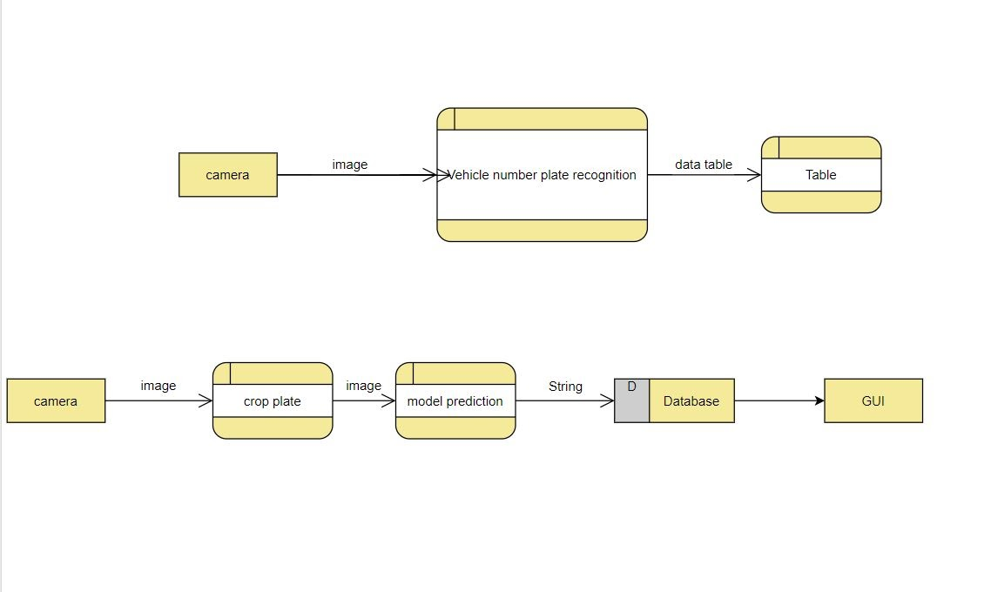

* **Technology used:**
* Software Requriements:

1. Python: Programming language
2. Jupyter Notebook:
3. MySQL client software.
4. MySQL server software.

* Thridy party libraries:

1. OpenCV2 >= 4.0.0.0
2. Pytorch
3. Tkinter
4. Numpy
5. Albumentations
6. PIL
7. Scikit-learn
8. glob
9. tqdm
10. opencv-contrib-python
11. mysql-connector-python

* **Details Of Hardware and Software**

|  |  |
| --- | --- |
| System | Minimum requirements |
| Operating System | Windows: 8, 8.1, 10 or higher.  MacOS:  Linux: Supports Redhat, Arch, Linux Mint, Ubuntu distros only. |
| CPU | Compatible with any Desktop CPU architecture. |
| RAM Capacity | 2GB or greater |
| GPU | (optional) CUDA supported Nvidia GPU for training and inferencing a model. |
| Extra Hardware | |
| Digital/Surviellance Camera with flash light. | Pixel Count: 2MP or greater.  Aperture: anywhere between f/1.2 to f/5.  Frame rate: 24fps or greater. |

**Analysis of Algorithm**

* **DFD /sequence diagram**

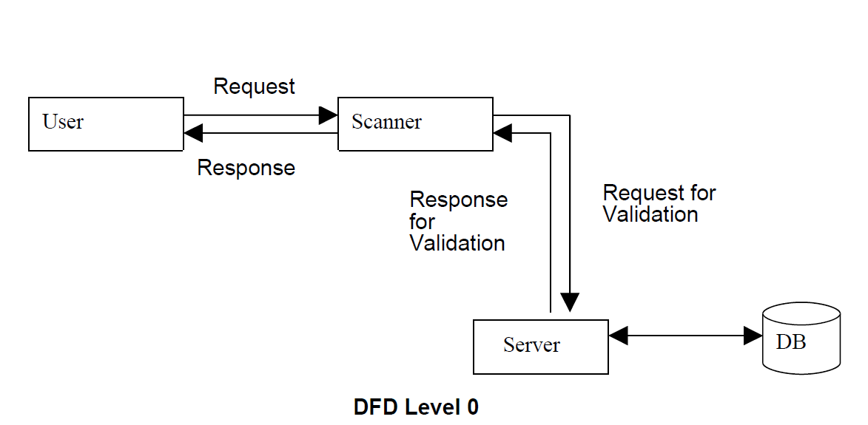

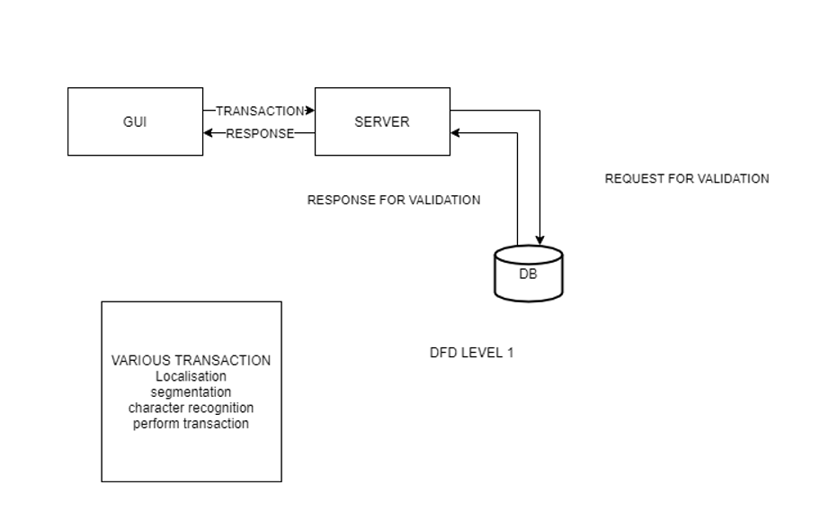

* **PERT/Gantt chart**

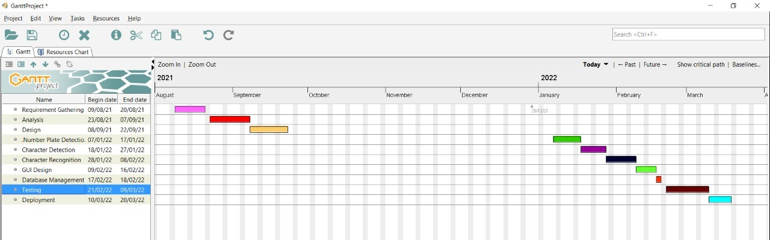

**RESULTS AND DISCUSSIONS**

Due to the rise of machine learning, there is a rise in such systems. Our system no doubt has the capability to use in various parts of the world.Through this we can decrease the rate of theft and crime in any area due to constant monitoring and easy to access the data of any vehicles number plate which was scanned by our software

**CONCLUSIONS AND FUTURE SCOPE**

This paper has attempted to provide a survey of research on LPR algorithms and to offer addressing of some categories of the methods used in references. This paper discusses the techniques of number plate detection, character segmentation and character recognition. Though there are several commercial LPR systems, briefing the techniques used in these systems is beyond the scope of this paper, as their operation is strictly confidential LPR can be a measure of vehicle identification, it may be further exploited for vehicle model identification and speed estimation. The measure of section travel time could be useful in traffic management, planning and control. Increased mobility and globalization set the challenges of developing effective LPR system that could handle plate from various countries with different character sets and syntax. Most LPR system focuses on processing of one nameplate in the image. But, as, input image may contain more than one name plates; the future challenging taskis to detect these plates.

**REFERENCES**

[1] Sourav Roy, Amitava Choudhury, Joydeep Mukherjee.,” An Approach towards Detection of Indian Number Plate from Vehicle” International journal of Innovative Technology & Exploring Engineering (IJITEE)Volume-2, Issue-4, March 2013

[2] Shan. Du, Mohamed. Shehata, Wael. Badawy,”Automatic License Plate Recognition(ALPR):A State-of –the-Art Review” IEEE Vol. 23, No.2, June 2013.

[3] P.Anishiya, Prof. S. Mary Joans,” Number Plate Recognition for Indian Cars Using Morphological Dilation and Erosion with the Aid of Ocrs.” International Conference on Information and Network Technology, Vol.4, 2011.

[4] Weihua Wang, "Reach on Sobel Operator for Vehicle Recognition, "International Joint Conference on Artificial Intelligence, pp.448-451, 2009

[5] Saeid Rahati, Reihaneh Morvejian, Ehsan M. Kazemi and Farhad M. Kazem “Vehicle Recognition Using Contourlet Transform and SVM,” Proceedings of the Fifth International Conference on Information Technology, 2008

[6] M.A. Sotelo , J. Nuevo , L.M. Bergasa and M. Ocana,“Road Vehicle Recognition in Monocular Images,” IEEE Symposium on Industrial Electronics, 2005

[7] SaimaRafique, Mahboob Iqbal and Hafiz Adnan Habib,“Space Invariant Vehicle Recognition for Toll Plaza Monitoring and Auditing System”, Multitopic Conference, 2009. INMIC 2009,IEEE 13th International, pp. 1-6

[8] Bone P, Young R, Chatwin C. “Position, rotation, scale, and orientation-invariant multiple object recognition from cluttered scenes,” Opt Eng2006; 45:077203

[9] Xiaojun Zhai, Faycal Bensaali and Reza Sotudeh, “OCR-Based Neural Network for ANPR” in IEEE, 2012. Pp1

OpenCV Python docs: <https://docs.opencv.org/master/d6/d00/tutorial_py_root.html>

Haar features: <https://www.youtube.com/watch?v=F5rysk51txQ>

Pytorch docs: https://pytorch.org/docs/stable/index.html

Text Recognition Architecture: https://www.youtube.com/watch?v=IcLEJB2pY2Y&t=3161s